WIDE SHANK COUPLERS

Nomenclature. The manufacturer refers to the three castings as the “upper drawbar half”, “lower drawbar half” and “knuckle”. To simplify, I’ll call the upper casting the “main” and the lower casting as the “arm”.

Center opening/mounting lug diameter comparisons.
Center hole in shank =
Drill bit #30 = .126" [too large] Drill bit #32 = .114" [too small]
Kadee #5 post on cover = .123 Closest router bit = .121

Note: In order to insure good operation of the couplers, the three castings (main, knuckle and arm) should be cleaned, grit blasted and airbrushed separately prior to assembly.

CLEAN THE CASTINGS

1. General. The manufacturer’s instructions advise you to smooth two areas: (a) scrape flash from inside base of knuckle and (b) file rough edge of “arm” on knuckles. However, after examining several castings, both arms and main, I did not find any flash. Nevertheless, scrutinize the castings before mounting them on the jigs for grit blasting.

2. Main Castings.

A. Almost every main casting has flash in the hole on the shank. Clean the hole with a 60 drill bit.

B. A few castings may have a deformed hinge pin. Check for this possible defect.

C. Some of the castings that were finished in a copper color have an overall rough finish that must be filed smooth at critical areas.

3. Knuckle Castings. Clean the holes for the hinge pins after painting and weathering. See the section on assembly. Note: I reviewed pages 7-8 of Sergent’s instructions which require much fussing with the knuckle castings. None of it applies to what I have. They must have been written before Sergent perfected the manufacturing process.

Note on walnut hulls. On every casting, clean the hinge pin holes with a #75 drill bit. As a final step in the casting process, the castings are tumbled in walnut hulls to remove flash and improve the surface quality. Sometimes little bits of walnut hulls end up getting lodged in the castings - particularly in the hinge pin holes on the tiny knuckle castings. If left there, this material will cause the coupler to require more force than it should to open and close. After the plating process, the walnut hull bits turn bright orange and so are fairly apparent. You can see it in the two middle knuckles in the picture. You can easily pick the material out of these holes with the tip of a hobby knife. Just be on the lookout for it.
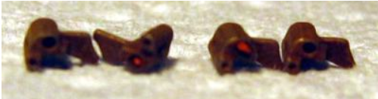

Note: to disassemble a coupler, soak it overnight in acetone. By then all traces of the adhesive will be gone.

JIGS

Preliminary. When I first began assembling Sergents, I created the following jig from a modified clothes pin for mounting the lip of the knuckle for grit blasting and painting. Making several jigs was time-consuming and mounting the lips was difficult. More recently I created the much more user-friendly plastic jig described below.

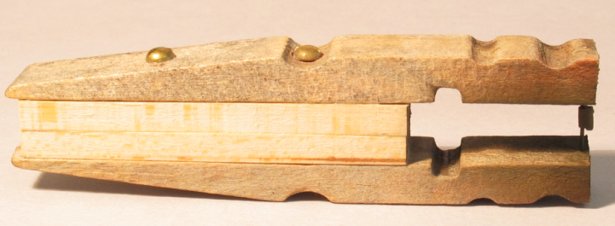 | 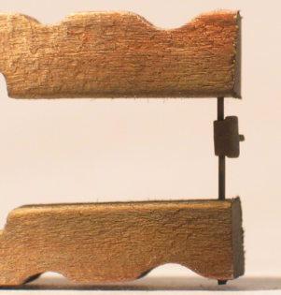

1. Plastic Jig For Knuckles.

A. Making the Jig. On 9/28/22 I made a jig for 20 castings from Evergreen styrene strips. It is a sandwich of 2 strips of .125 x .250 with sections of .020 x .250 in the middle with gaps in between. See enlargement photo below on the left. I was careful to use a middle strip that was exactly .020 thick. I had to cut 21 short pieces from the .020 x .125 strip. After sawing each one of the .020 pieces, I had to file the debris off the ends to maintain a constant .020 thickness. I spaced the pieces on a strip of .125 x .250 a little wider apart from each other than the width of the flat protrusions on the knuckles, then glued them with Testors on the .125 x .250 strip. The flat protrusion on a knuckle is .023 thick, so it fits tight in the slots created by gaps in the middle .020 thick strip. Two lengths of 1/2 inch square basswood strip were added as a “handle” which is necessary when using the bulky gloves in the gritblaster.

B. Using the Jig. Knuckles were mounted in the slots by griping the top and bottom edges with the blue-handled pliers. I used the Optivisor when inserting the flat protrusion in the slot to make sure I didn’t widen the slot by angling the casting instead of pushing it straight in. One of the knuckles fit too loosely in the slot, so I brushed a little Testor’s around to tighten it up. I gritblasted the knuckles at 45 pounds pressure and the grit penetrated virtually every surface of the knuckles. The two photos below on the right show the position of a knuckle in the jig after gritblasting.

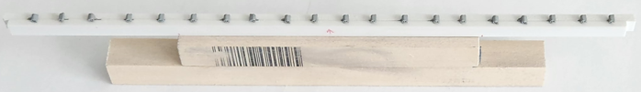 | 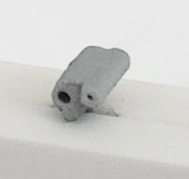
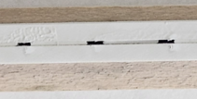 | 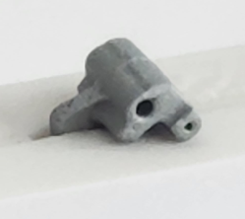

2. Jigs for the Main and Arm.

A. Make the Jigs. For ten pair of coupler castings, cut a 6-inch length from a 1/2 square strip of basswood. Then cut a second strip to make a “T”, as in the photo below. Attach it to the top of the “T” with two screws. Mount the main castings with a 3 x 1/2 wood screw. Mount the arms by pressing then in .064 drilled holes. Then make a second jig so you can work on 20 couplers.

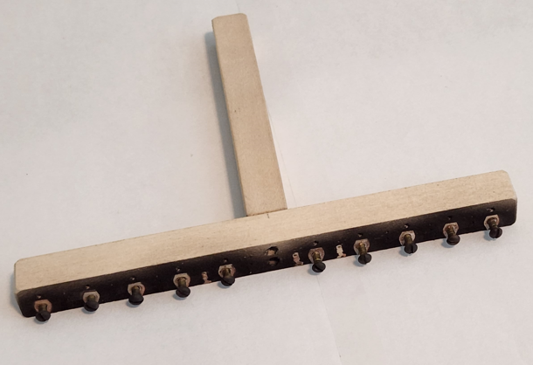 |  | 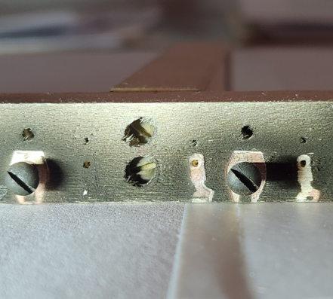
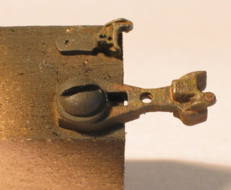 | 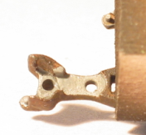 | 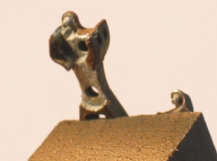

PAINTING

1. Grit Blasting. Mount 20 of each of the three castings in the jigs. Grit blast the castings at 4.5 (on the dial) air pressure.

2. Ultrasonic. Clean the castings in the ultrasonic, then let the parts dry on toweling paper.

3. Painting.

A. Repeat step 1.B under “Jig” to mount the three castings for painting.

B. Spray a light coat of Floquil Roof Brown and Rust (half and half mixture) on the castings. To avoid getting any paint on areas that are critical to the Sergents working properly, begin by shooting straight down from the top. Do two more low profile passes at the angles indicated by the arrows in photos 1 and 3. In photos 2 (main) and 4 (arm), hand-paint the highlighted areas, being careful not to get any paint on the pivot pins. Let the castings dry for a full week before removing them from the jig. Following this procedure avoids having to mask areas on the castings.

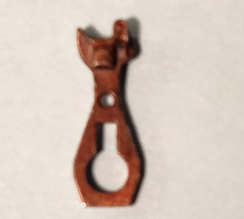 | 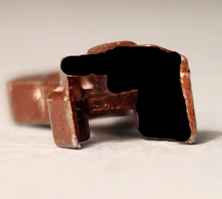  Pivot pin | 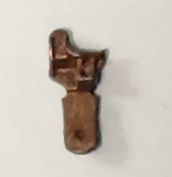 | 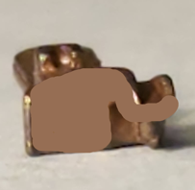  Pivot pin
1 | 2 | 3 | 4

C. With the castings still in the jigs, darken some Floquil Southern Freight Car Brown with some Engine Black, then thin it with Diosol. Use the red-handled 10/0 Pactra red sable brush #B302 to brush on a light coat. Wait a few minutes for the paint to dry.

D. With other castings still in the jigs that have not been painted per “C” above, brush on some Floquil Rust. You may or may not have to thin the paint. On 10/7/22 I used paint from bottle #17a without thinning it. However, the paint dried shinny so I had to overspray the couplers with Dullcoat. Test paint for thickness and finish before using it if any doubt about these aspects.

Another possibility. With the castings still in the jigs, using the red-handled 15/0 Pactra red sable brush #B301 (Jerry’s Artorama #???), dry bush a very light coat of Floquil Rail Brown on the protruding surfaces of the castings. Let the paint dry for another week. Note: Doing this step is questionable - adds an odd color. Parts looked great after completing step 8 on 11/29/17.

5. Cleaning. Remove the castings from the painting jigs. Inspect the paint job to make sure no paint will interfere with the movable parts of the castings.

ASSEMBLY

1. File smooth both sides of the flat “arm” on the knuckle. Use a small file and hold the casting between your fingers. See photo B. Then clean the hinge pin holes with a #75 (.020) drill bit. With a low speed, just touch the openings of the holes without pushing into them.

2. Cut a short piece of the thick white double-sided tape and position it on an angle, then stick the silver-colored factory assembly jig on it. Seat the main casting on the jig, as per photo A below. Use the flat end of a wood dowel to seat it flat.

3. Place the knuckle in position. Use the fine-pointed tweezers to grip the flat area, position the casting as per Photo C, then lower and press it in place.

4. Touch one tip of the fine-pointed tweezers to a steel ball. The ball will stick to the point magnetically. Position the ball near the depression in the main casting, then use the point of a toothpick to release the ball from the tweezers and drop it in the depression. See photo D.

5. Place a small drop of cyanopoxy (or thick ACC that will not run) on the main casting away from the ball. Place a little more glue around the pin of the arm. Don’t add more glue in the knuckle area.

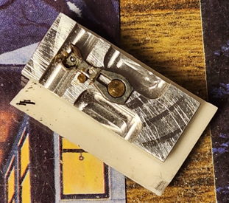 | 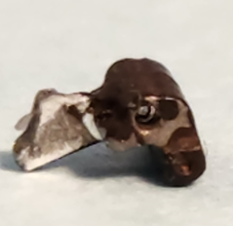 | 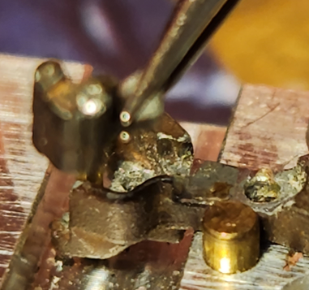 | 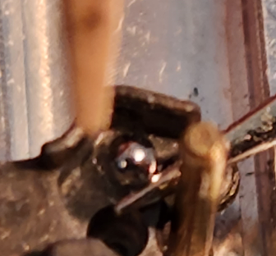
A | B | C | D

6. With the assembly jig still on the double-sided tape, grip the arm casting (photo below), then from the rear move forward and set and press it on the main casting. Apply pressure until the glue dries.
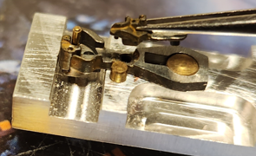
FINAL WEATHERING

Consider dry brushing on diluted rust-colored or other color paint to weather the Sergents a little more after they have been assembled. Finally, do not add any powdered graphite, using the Kadee dispenser, into the interior knuckle area to enhance free movement. That would definitely impede free movement of the ball.

INSTALLING THE COUPLERS
COUPLER HEIGHT

The correct height of Kadee couplers from the top of the rail to the center of the knuckle is 25/64 inches. When I first began using Sergents I was unable to find any indication at the Sergent website or elsewhere what the correct coupler height should be, so I decided to use what Kadee specified. I made a coupler height gauge and test track by gluing and spiking a length of Shinohara code 100 track to a piece of 1 x 2 pine. At one end I screwed a short length of 1/2 inch square basswood to the pine base. I shimmed the basswood with styrene strips so that the overall height of the basswood and styrene was exactly .524 inches. To the top of the basewood I screwed an assembled Sergent coupler. This put the height at the center of the knuckle at exactly 25/64 inches above the railhead. Every Sergent I have installed is checked against the height gauge.

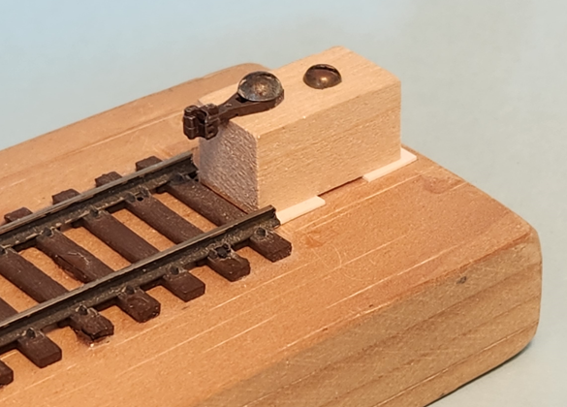

SERGENTS IN KADEE BOXES

Place the bottom box-shaped Kadee #5 casting upside down on the underbody with the front edge even with the front edge of the end sill. Place a pin mark on the underbody centered in the center hole of the box. Set the dividers at exactly 13.5 HO scale inches. Use the points of the dividers to make two points, each one exactly 13.5 inches from the center point. Enlarge the points with the small punch. Decide whether to (a) drill and tap the holes for NWSL 1.4 x .3 x 6 mm machine screws or (b) drill holes for wood screws.

SERGENTS IN McHENRY BOXES

Notes.

A. When I installed Sergents on the Railworks Rutland combine it was necessary to raise coupler height by eliminating the thin part (with the "ears" on it) of a Kadee draft gear box and use only the three-sided cover. The centering boss on the thin part had to be cut off and glued to the cover - a real pain. I found that an easier way to do this kind of arrangement is to use the box part of a McHenry gear box because the mounting boss is molded on it. I was able to buy some old packages of McHenrys with gear boxes on E-Bay on 1/15/15 but, per the parts department at Athearn where McHenrys are made, the gear boxes are no longer manufactured. The only other draft gear boxes that have the mounting boss molded on a three-sided cover are those that come with the Lifelike Mather boxcars and stock cars. I could use parts from those kits because I substitute Kadee boxes for the Mather cars. Of course, I could always use Kadee boxes. It's possible that the enlargement boss that comes with Bowser hopper cars could be used with a center screw instead of cutting and remounting the Kadee centering boss.

B. The specifics below are for the copula end of one of my two high cupola Rutland cabooses. More specifically, it's for the caboose that has less solder on the brake lever where it meets the brake cylinder. Because these are brass cars as opposed to an injection molded model, the measurements indicated below will probably vary somewhat from model to model and maybe even from one end to the other on the same model.

C. Follow the same procedure below for the center cupola caboose and the two window caboose, except the rear of the box will have to be removed and the boxed glued in place so the coupler doesn't stick out too far from the edge of the end sill.

D. The B&M caboose is a hair low with a standard Kadee box, so raise the height of the car with a washer at the truck.

Procedure.

1. Reduce the thickness of the McHenry coupler box from .116" to .095". Be careful to keep the reduction even on all sides.

2. Mount a Sergent coupler with two black screws instead of a center screw.

3. Add one Kadee red washer (.014") to get the correct height.

NARROW SHANK COUPLERS

1. Accurail Coupler Box Modifications. The two castings do not line up at the open end because the attachment holes/pins are off, as well as the screw mounting holes. To correct, enlarge the attachment hole on the right??? side, looking at the coupler from the open end with the top (smooth exterior casting) on top, with a #56 bit. Then enlarge the screw mounting holes with a #48 bit.

2. Modifications to Car Kits to Install Accurail Coupler Boxes. Since most kits are made to accept Kadee #5 couplers, either in a Kadee box or via a molded box as part of the underframe, the question is what modifications are necessary to replace the box with an Accurail exact scale box with Sergent narrow-shank couplers. The measurements below indicate that an Accurail box should be mounted .004" higher than a Kadee box. This would be accomplished by either (1) routing the underside of the floor casting .004" deeper than what it is, or (2) adding washers between the trucks and underbody.

